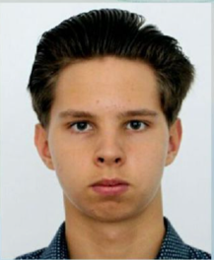

Experience
- Working Experience in Web design. Web applications on Django framework with own design.

- Worked with Django, TeleBot, requests, Beautiful Soup.

- Working Experience in machine learning, python libraries for AI (PyTorch, Keras, Jupiter notebook, torchvision, sklearn.metrics)

Understanding of algorithms and data structures.
- Data analyzing with Python (mathplotlib, numpy, pandas)

Strong knowledge in mathematics and analytical skills.

3 years programming experience in Python.

Education

Republican Physics and Mathematics School in Almaty

Certifications
Python programming (certificate): Yandex Academy course in industrial programming in Python, duration 2 years. Machine learning scientific program (Nazarbayev University).
Programming Languages: C++, Python, CSS, HTML, JavaScript. Github: https://github.com/Boris2232§

About me
I’m a team player, one of my hobby is a basketball. I lead a healthy lifestyle, regularly go to gym. My favorite occupation is solving problem on Leetcode site, creating web projects and studying machine learning algorithms.
Phone:
+7 747 97 97 103

E-Mail:
boris.dubovoy23@fizmat.kz

Skill Highlights
- Working Experience in Web design and machine learning .
- Complex problem solver
- Creative approach to problem solving
- Innovative
- Analytical and mathematical skills
- Patience and diligence

Languages
English Language C1. IELTS band 7.0.
Kazakh language advanced level.
Dubovoy Boris

